FACULTY MEMBERS OF S&T TRAINING CENTRE, E.C.RAILWAY, DANAPUR

**Sri Rajesh Saran**

**Principal**

**9771449807**

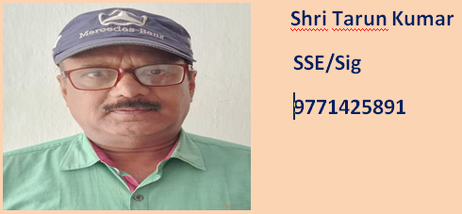

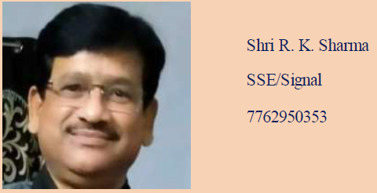

**Smt. Kumari Divya**

**SSE/Signal**

**9267474300**

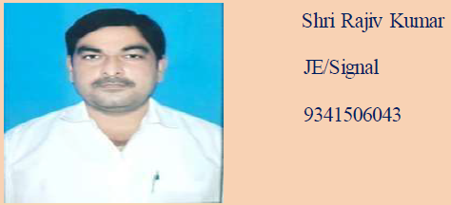

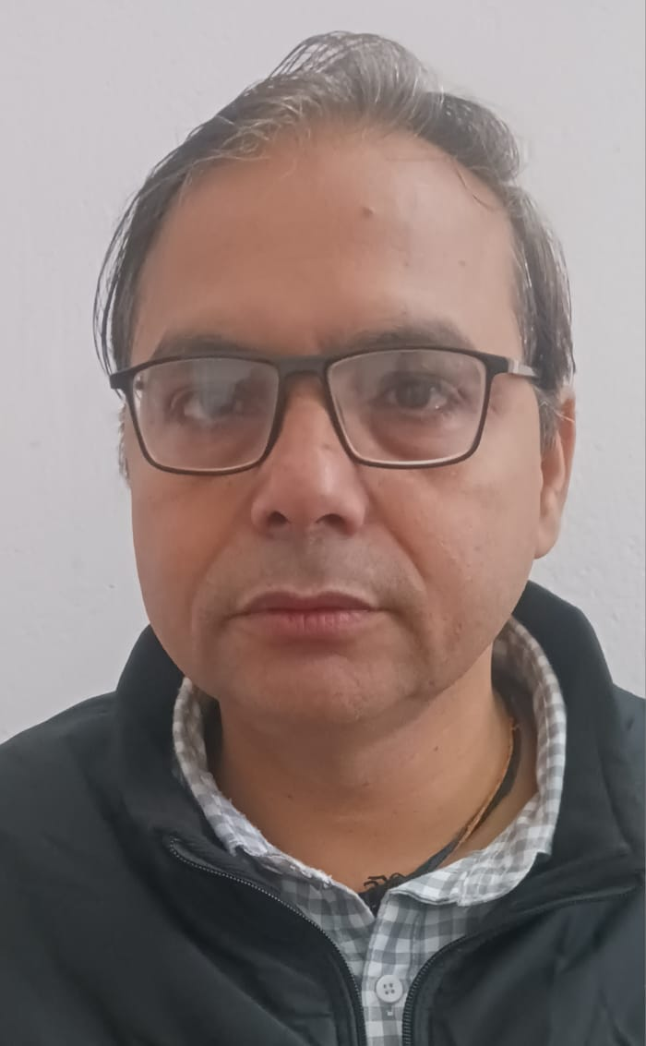 **Shri Samir Kumar**

**SSE/Tele**

**7541806933**

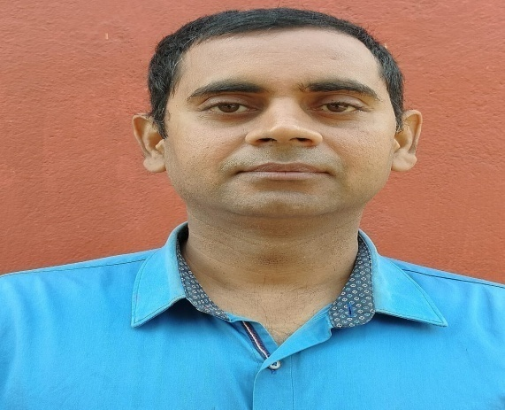 **Shri Abhinaw Nath**

**SSE/Tele**

**7319942467**